Operation Manual
Team 504: Water Filtration System
Sponsored by Apollo Renal Therapeutics, Artemis Plastics LLC.

Name: | Email:
Kencin Autry | kba20a@fsu.edu
Matthew Kennedy
Lapadre Proctor | ljp20@fsu.edu
Timothy Norman
Lily Thompson | lat20d@fsu.edu

FAMU-FSU College of Engineering
Florida State University
Dr. Shayne McConomy
March 29th, 2024

Table of Contents
I. Project Overview 2
II. Component and Module Description 2
II.I Reverse Osmosis System 2
II.II Peristaltic Pump 3
II.II.I Arduino Code 3
II.II.II Wiring Diagram 4
II.III CNT Filter Housing 4
III. Integration 6
IV. Operation 6
V. Troubleshooting 7
Appendices 7

Project Overview

The objective of this project is to reduce the quantity of wastewater in the dialysis process by efficiently purifying standardized filtered water and spent dialysate to ultra-pure water. To reach this objective the system will purify tap water to ultra-pure standards to pump into a dialysis machine, the wastewater from the dialysis process will then be recycled through the system.

Component and Module Description

II.I Reverse Osmosis System
The reverse osmosis machine that is being used is the NU Aqua 600 GPD Tankless RO system. This system needs a sink or a water input source with a pressure between 14.5 and 58 psi. It is designed to be operated under a sink but requires drilling and adjusting pipes underneath the sink. To avoid doing that a connector is needed and some of the parts given are not used such as the leak stop valve, drain saddle, and feed water adapter. This machine's installation manual is left in the box and is linked in the appendix A.
The RO system was ordered off NU Aqua, the reason we ordered it off that website was because it was the manufacturer’s website. The reason we chose that specific RO system as compared to a 6 stage or a different system was because of the flow rate it had and the size of it. When we were looking at other RO systems at that time, all other systems seemed to be much larger than what our size dimensions needed to be, and this was the closest in size that we could find to match our dimension requirement. It also had the highest flow rate compared to other RO systems at that size.

Connections:
Use a connector with 3/8” diameter with a threaded end and an open end which can connect to the 3/8” piping. The threaded end screws into the sink faucet and that piping is plugged into the port labeled “Input” on the RO both sides of the piping should be secured with 3/8” retaining clips. To avoid leaking, that threaded end should be wrapped with thread sealant. The drainpipe is 1/4” and this should be plugged into the RO and secured with a 1/4” retaining clip and routed into the sink or a reservoir. The faucet that comes with the RO goes into the plug labeled “faucet”, 1/4” piping connects into the bottom of that faucet and into the RO system port labeled “Pure” both connected sides should be secured with 1/4” retaining clips. With all these pipes connected slightly tug on these pipes to ensure they are secure. Lastly the power supply is plugged into the wall and into the RO system all the required connections are now made.

II.II Peristaltic Pump
Components
- 1 Arduino Microcontroller
- 1 TB6600 Stepper Motor Driver
- 1 12 V Power Supply
- 1 24 V Stepper Motor Peristaltic Pump with adjustable speed up to 1600 mL/min
The peristaltic pump we ordered was from a manufacturer called Kamoer and it was ordered off Amazon because it was in the Spear-mart approved vendors. As for the manufacturer, we went with this specific brand/model because it appeared to be a very small pump as compared to others we saw when looking. It also had a much higher flow rate than what we required, which was a nice thing to have. Finally, the price was very cheap considering the flow rate we were getting, along with size and quality.

II.II.I Arduino Code

The code used in Arduino Mega controls the rotation of the stepper motor serving to adjust the speed of the input flow to the hemodialysis machine. The full code can be found in Appendix B. The following is a detailed explanation of the code, refer to Appendix C to follow along with the explanation.
Three digital pins are configured “stepPin”, “dirPin”, and “enPin” to control the step signal, direction of rotation, and to enable/disable the motor driver. In the setup section of the code the digital pins are declared as outputs, meaning they interact with external devices. The pin “enPin” is then declared as LOW to enable the motor driver.
In the loop section of the code, the iterations of the cycles are established to drive the stepper motor. The digital pin “dirPin” is declared HIGH to turn the stepper motor to the left. A “for” loop is declared to generate step signals to drive the stepper motor. Each iteration of the loop triggers a step signal by setting the “stepPin” to HIGH, advancing the motor by one step. To control the speed of the motor, the code introduces a precise delay using the delayMicroseconds() function. This delay ensures that each step signal is generated at the desired rate, allowing for smooth and controlled movement of the motor.
Following the step signal, the “stepPin” is set to LOW to complete the step signal cycle. This sequence of setting the “stepPin” to HIGH, introducing a delay, and then setting it to LOW is repeated for a predetermined number of steps—in this case, 10,000. This loop structure enables the code to drive the stepper motor in a consistent and controlled manner, facilitating precise movement according to the specified parameters. Additionally, a brief delay of 1 millisecond (delay(1)) is introduced between iterations of the loop. This delay serves to regulate the frequency at which the loop executes, ensuring that the motor operates at the desired pace and allowing for smooth transitions between steps.

II.II.II Wiring Diagram

The wiring diagram for the peristaltic pump is shown in Figure 1. It includes the connection between the Arduino microcontroller, stepper motor driver, stepper motor, and power supply.

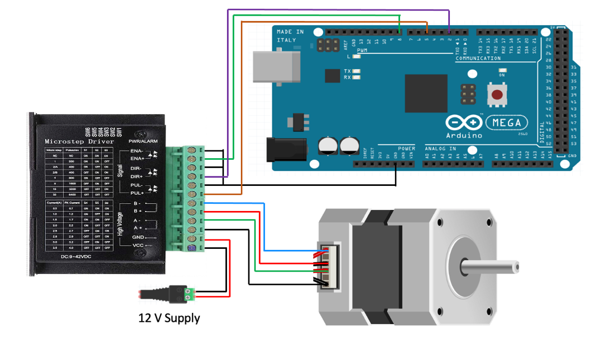
Figure 2.2.1: Wiring Diagram

II.III CNT Filter Housing

The housing was created through SolidWorks and was 3-D printed in PLA on a Creality printer. The reason it was 3-D printed was due to the cheap cost of the PLA and if it were to be machined out of metal, it may contain trace amounts of residual metal from the machining process which cannot enter the dialysate. The metal also may contain some toxins that cannot be in the dialysate either. 3-D printing also allowed us to achieve designs that may not have been feasible if it were to be machined. The PLA was ordered off Amazon and the brand was Overture. The reason Overture’s PLA was chosen is because it was at a competitive price and the quality of Overture’s PLA is quite good as compared to other plastics on the market. The figures below show the CNT Housing.

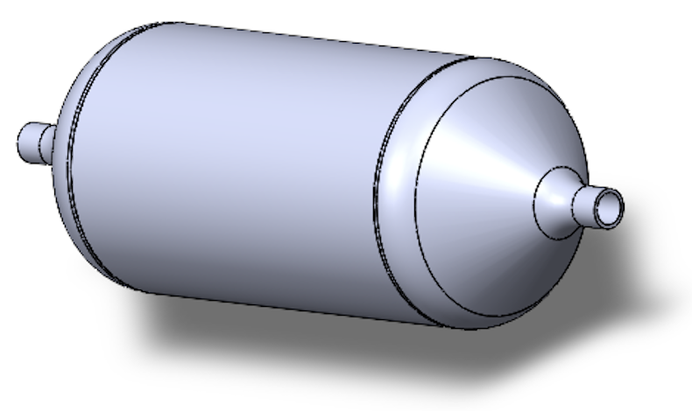
Figure 2.4.1: Enclosed Housing

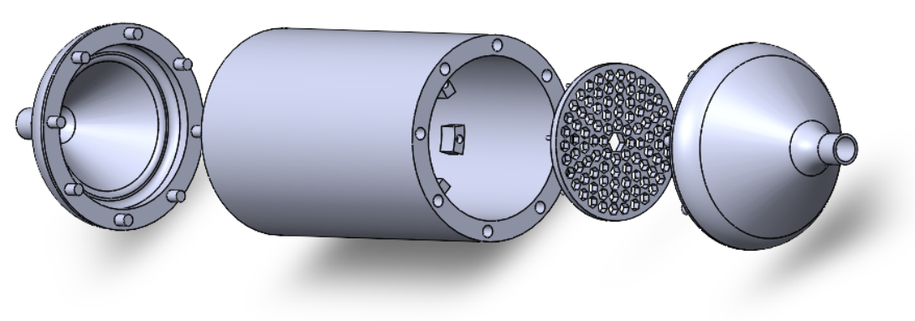
Figure 2.4.2: Exploded View of Housing

Integration

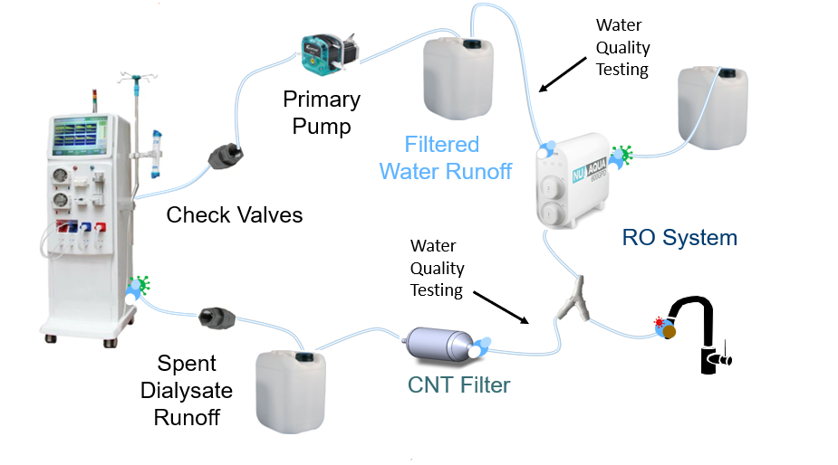
Figure 3.1.1: Full System Image
To integrate each component of the system it begins with the RO system and the tap. The RO is connected to the sink using a 3/8-inch threaded adapter that feeds the main water supply into the RO. The RO output is separated into a drain and a secondary faucet attachment. The secondary faucet attachment then directs into a filtered water runoff reservoir using 3/8- inch inner diameter clear vinyl tubing. The primary pump is then used to pump this runoff water into the dialysis machine using a check valve to connect and ensure the flow rate. Since there is no actual dialysis machine, the primary pump is then used to direct the spent dialysate into the CNT filter housing using another check valve, runoff reservoir and the 3/8 tubing. The CNT outlet has 3/8 tubing directly attached and leads to a Y-connector that splits the input water for the RO system between the tap water and the CNT filtered water. The primary pump and RO system are integrated using the methods shown in Sections II.I and II.II.

Operation

Follow the steps to begin system operation:
- Connect RO system to sink faucet or water supply.
- Connect tubing from the primary pump to the dialysis machine using the Hansen connector.
- Connect the exit tubing to the dialysis machine using the Hansen connector for the outcoming flow.
- Turn on sink faucet to halfway to direct pressurized flow to RO system.
- Turn on outlet faucet from RO system to direct filtered water to the rest of the system.
- The water should now all be flowing throughout the system.

Troubleshooting

If the RO system does not filter properly

- Ensure the system has run for 30 minutes before filtering any fluid.
- Red Light above filter indicates it needs to be replaced.
- Red light on the RO faucet indicates it needs to be replaced.

If the RO system does not work

- Check the power connection to the system.
- Check the connection to the faucet or water supply.
- Check the power connection to the output faucet.

If the pump does not work (i.e. The drive shaft isn’t rotating, no power, etc.)

- Check to see if all the connections are wired incorrectly.
- Check to see if the power supply is connected to the wall.
- Check to see if the code has been compiled and uploaded.

Appendices

A. RO System Manual

https://cdn.shopify.com/s/files/1/0033/6625/6689/files/600gpd_manual-compressed_1.pdf?v=1697051803

B. Arduino Mega Code

const int stepPin = 5;
const int dirPin = 2;
const int enPin = 8;

void setup() {
pinMode(stepPin,OUTPUT);
pinMode(dirPin,OUTPUT);
pinMode(enPin,OUTPUT);
digitalWrite(enPin,LOW);

}

void loop() {
digitalWrite(dirPin,HIGH);
for(int x =0; x<10000; x++){
digitalWrite(stepPin,HIGH);
delayMicroseconds(70);
digitalWrite(stepPin,LOW);
delayMicroseconds(70);
}
delay(1);

}

C. CNT Filter Housing CAD Drawings

